Some and Any

❓ What Are Some and Any (as Quantifiers)?
# Source: AI Source: Provided by: [Data Path: Persons Table -> ID Column: 1, Name_En Column: Motasem Essam] -> From: [ChatGPT] on [7/28/2025]
"Some" and "any" are quantifiers used to talk about an unspecified amount or number of something — not exact, but more than none.
They are used with both countable and uncountable nouns.

✅ "Some" – Use & Examples
# Source: AI Source: Provided by: [Data Path: Persons Table -> ID Column: 1, Name_En Column: Motasem Essam] -> From: [ChatGPT] on [7/28/2025]
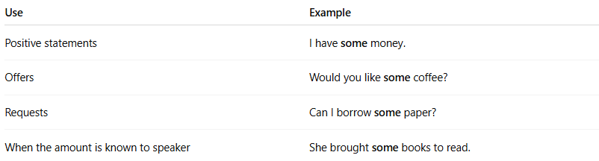
Use | Example
Positive statements | I have some money.
Offers | Would you like some coffee?
Requests | Can I borrow some paper?
When the amount is known to speaker | She brought some books to read.

✅ "Any" – Use & Examples
# Source: AI Source: Provided by: [Data Path: Persons Table -> ID Column: 1, Name_En Column: Motasem Essam] -> From: [ChatGPT] on [7/28/2025]
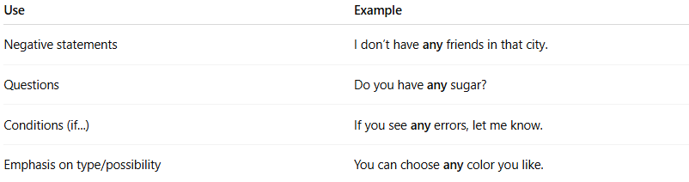
Use | Example
Negative statements | I don’t have any friends in that city.
Questions | Do you have any sugar?
Conditions (if...) | If you see any errors, let me know.
Emphasis on type/possibility | You can choose any color you like.

📌 Quick Comparison:
# Source: AI Source: Provided by: [Data Path: Persons Table -> ID Column: 1, Name_En Column: Motasem Essam] -> From: [ChatGPT] on [7/28/2025]
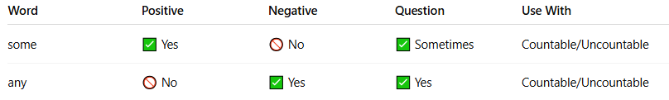
Word | Positive | Negative | Question | Use With
some | ✅ Yes | 🚫 No | ✅ Sometimes | Countable/Uncountable
any | 🚫 No | ✅ Yes | ✅ Yes | Countable/Uncountable

🧠 Examples with Both:
# Source: AI Source: Provided by: [Data Path: Persons Table -> ID Column: 1, Name_En Column: Motasem Essam] -> From: [ChatGPT] on [7/28/2025]
- ✅ I have some apples.
- ❌ I don’t have any apples.
- ❓ Do you have any apples?

